Go Safely Movement Email Template

Dear [Name],

We are experiencing a crisis on our roadways. Traffic crashes account for nearly 10 percent of all deaths in the United States, with thousands of lives lost every year on California roadways. We need your help to address this public safety crisis!

To reduce serious injuries and death on our roadways, the California Office of Traffic Safety is asking for your feedback on how to best address traffic safety concerns that you are facing in your community.

Join the Go Safely Movement and share your thoughts on what actions are needed to make our roads safer by taking the Community Call to Action Survey. The Go Safely Movement is a statewide call to action that aims to drive change and save lives by empowering communities to have a voice in making their streets safer.

Roadway deaths deserve more attention. We must create safer streets for all Californians - regardless of race, ethnicity, income, age or ability. Whether you bike, walk or drive, everyone should be able to travel to their destinations safely.

Californians can adopt a safety culture that benefits all who use our roads. Let's work together to end the roadway crisis and create a culture where safe drives save lives.

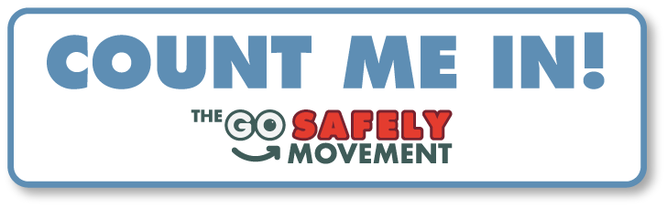

Thank you,

[Name]
[Title]
[Organization]

